FOOD INVENTORY FOR CAFETERIA
@CREATIVITY THINK (9483175986/7019689991)

ABSTRACT:
Food Inventory for Cafeteria is a DashboardApp designed to optimize cafeteria operations in schools, colleges, canteens, and cafes. Users can view menus, request or order food, provide feedback, and track stock changes in real time. Administrators manage food items, monitor usage and waste, reorder supplies, and analyze inventory data through dashboards. Built using Django and Django Rest Framework for backend operations and React with Recharts and Axios for interactive dashboards, the system ensures accurate food stock management, synchronized menus, supply chain efficiency, and reduction of food wastage..

INTRODUCTION OF THE PROJECT:
Cafeterias and food service providers often struggle to manage stock levels, reorder supplies timely, and reduce wastage. Food Inventory for Cafeteria provides a centralized dashboard for managing food stock, menu synchronization, supply chain tracking, and waste reduction. Users can view menus, request food, track stock changes, and provide feedback, while administrators can add or edit food items, monitor usage, reorder supplies, and analyze inventory data. Using Django for backend logic and React with Recharts and Axios for dashboard visualization, the platform ensures efficient and transparent cafeteria management..

PROJECT OBJECTIVES:

• Maintain real-time food stock tracking
• Provide reorder alerts for low stock items
• Synchronize menu items with available inventory
• Monitor supply chain and usage patterns
• Track food waste and generate insights
• Enable administrators to manage inventory and supply
• Generate dashboards and analytics for decision-making

PROBLEM OF THE STATEMENT:
Cafeterias face challenges in managing food inventory, tracking stock levels, avoiding wastage, and maintaining menu consistency. Manual tracking can lead to shortages, overstocking, and inefficient resource allocation. Food Inventory for Cafeteria addresses these problems by offering a centralized platform to monitor stock, manage supply, track waste, synchronize menus, and provide actionable analytics. Users gain visibility into food availability and usage, while administrators streamline inventory management, optimize supply chain operations, and reduce operational losses..

MOTIVATION OF THE PROJECT:
• Optimize cafeteria food inventory and reduce wastage
• Provide real-time stock visibility for users and admins
• Enable timely reorder alerts for efficient supply management
• Synchronize menu availability with stock levels
• Provide analytics for decision-making and cost optimization

BLOCK DAIGRAM OF PROJECT:

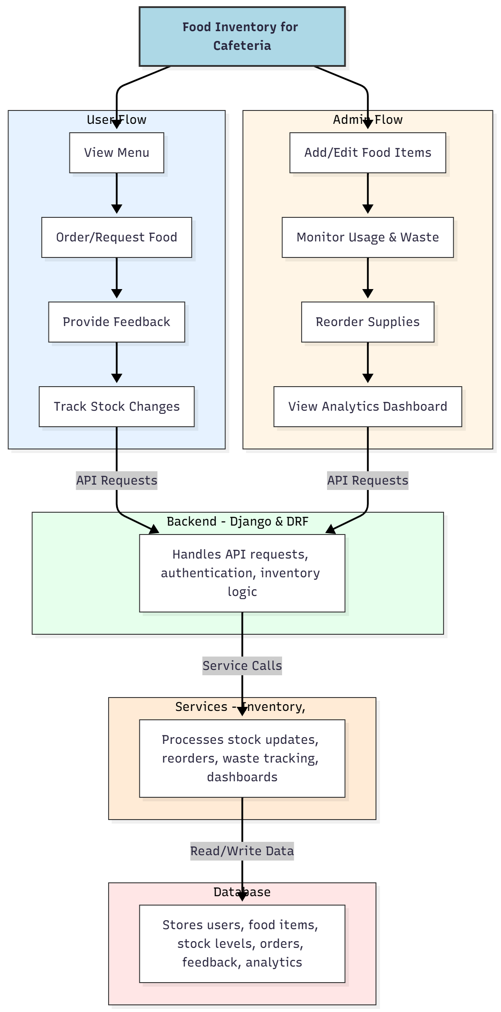

WORKING OF THE PROJECT:
Users view available menu items, place orders or requests for food, provide feedback, and monitor stock changes. The backend manages API requests, authentication, and inventory logic. Services handle stock updates, reorder notifications, waste tracking, and analytics dashboards. Administrators manage food items, monitor usage and waste, reorder supplies, and generate detailed analytics dashboards. The system ensures efficient inventory management, supply optimization, and reduced food wastage for cafeterias..

SOFTWARE REQUIREMENT:
- Backend:
  - Python 3.x
  - Django
  - Django REST Framework
  - SQLite/PostgreSQL
- Frontend:
  - Node.js and npm
  - React.js
  - Axios
- Development Tools:
  - Visual Studio Code
  - Postman (for testing APIs)
  - Git/GitHub (for version control)
- Server/Deployment (Optional):
  - Gunicorn, Nginx, or Heroku/AWS for hosting

ADVANTAGES OF THE PROJECT:

• Real-time food stock management
• Reorder alerts to prevent shortages
• Synchronization of menu with inventory
• Monitoring of usage and waste
• Analytics dashboards for inventory insights
• Streamlines cafeteria operations efficiently
• Reduces food wastage and operational costs
• Enhances decision-making for supply chain management

APPLICATIONS OF THE PROJECT:
• School and college cafeterias
• Canteens in offices and institutions
• Cafes and small food service providers
• Food stock and supply chain management
• Waste monitoring and reduction
• Dashboard analytics for inventory decisions
• User feedback tracking
• Centralized management of menu and stock

REFERENCES:

- Django REST Framework Documentation — Django Software Foundation. Django Documentation. Available: https://docs.djangoproject.com/
- Django REST Framework. DRF Documentation. Available: https://www.django-rest-framework.org/
- React. React Official Documentation. Available: https://reactjs.org/docs/getting-started.html
- Redux. Redux Documentation. Available: https://redux.js.org/introduction/getting-started
- PostgreSQL Global Development Group. PostgreSQL Documentation. Available: https://www.postgresql.org/docs/
- MySQL. MySQL Reference Manual. Available: https://dev.mysql.com/doc/
- Git. Git Documentation. Available: https://git-scm.com/doc
- Node.js. Node.js Documentation. Available: https://nodejs.org/en/docs/
- Axios. Axios Documentation. Available: https://axios-http.com/docs/intro
- Socket.io Documentation – https://socket.io/docs/

